Project 2: A better version of SDH computing program

Yu Liang

Course: CIS6930 Massive Parallel Computing

June 30, 2017

1. Overview

In this project I will measure the performance of GPU memory system, perform different experiments, and write a report on my findings. The problem in hand is: computing the spatial distance histogram of a set of points like the work in Project 1.

The main objective of this project is to write very efficient CUDA code. I have choose the techniques you learned from class to improve your program, which is managing thread workload to reduce code divergence.

1. Method

The method is to manage thread workload to reduce code divergence. In details, it is to move the workload in the second half of thread 1 to the first half of thread n. move the second half of thread 2 to the first half of thread n-1 and so on. In this way, the work load of each thread reduce into half. See below.

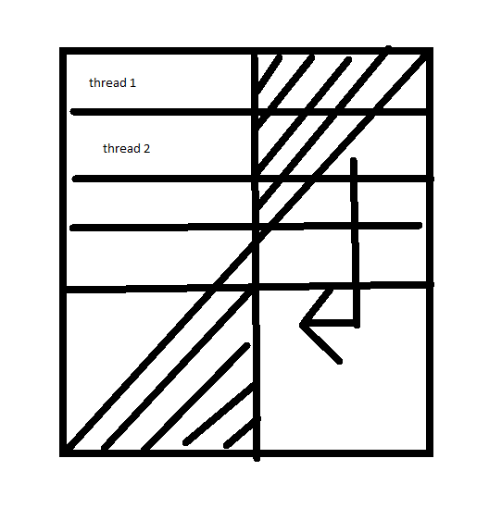

1. Result

In project 1, the time to generate SDH for sample size 512,000 is 107 seconds.



After managing thread workload, the time to generate is 86 seconds, which is 20% faster.

